RB01-Creating An Instance
Step 1: Open the EC2 Dashboard
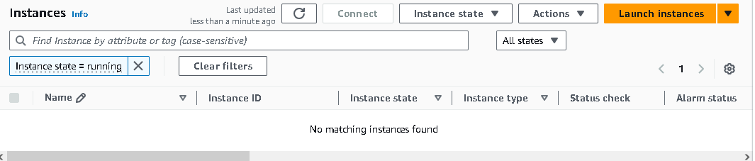

Step 2: Click the Launch Instance button.
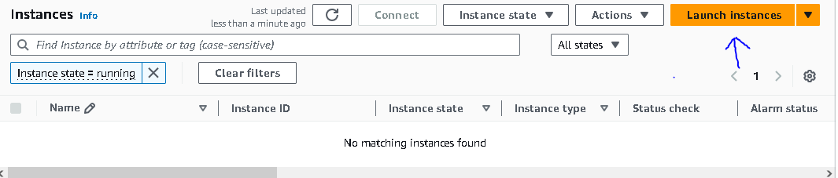

Step 3: Choose an Amazon Machine Image (AMI)
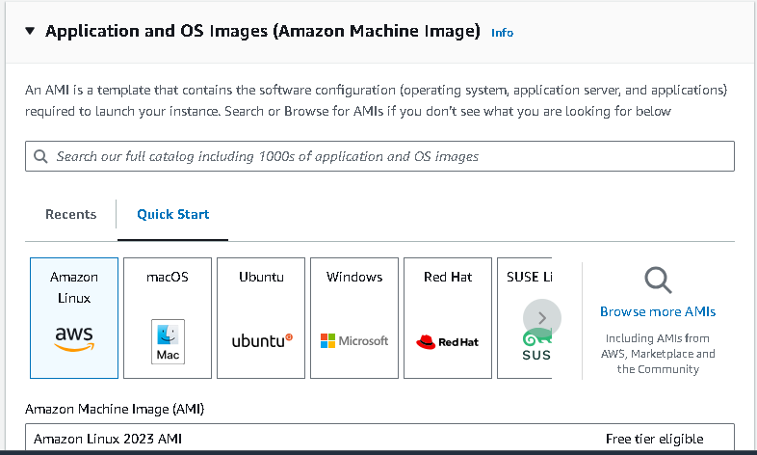

Step 4: Choose an Instance Type
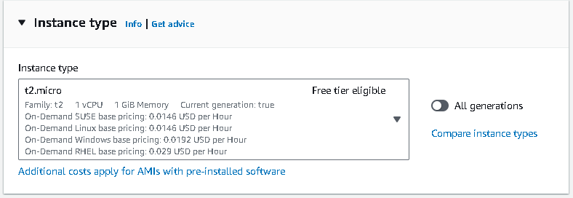

Step 5: Configure Security Group
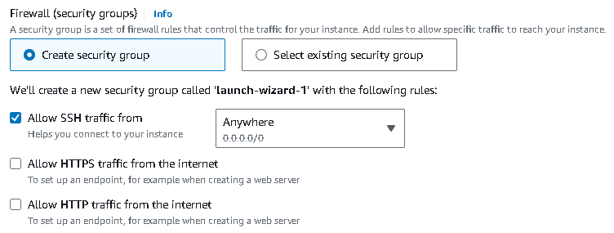

Step 6: Select a Key Pair
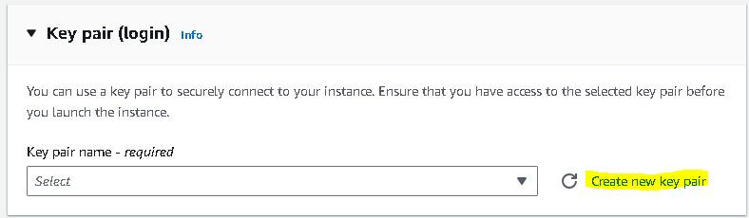

Step 7: Review and Launch
